Key Vocabulary
Light | Form of energy that travels in a wave from a source.
Light source | An object that makes its own light.
Dark | The absence of light.
Reflect | To bounce off.
Reflection | The process where light hits the surface of an object and bounces back into our eyes.
Shadow | An area of darkness where light has been blocked.
Ray | Waves of light are called light rays. They can also be called beams.
Opaque | Describes objects that do not let any light pass through them.
Translucent | Describes objects that let some light through, but scatter the lights o we can’t see through them properly.
Transparent | Describes objects that let light travel through them easily, meaning that you can see through the object.
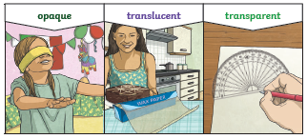
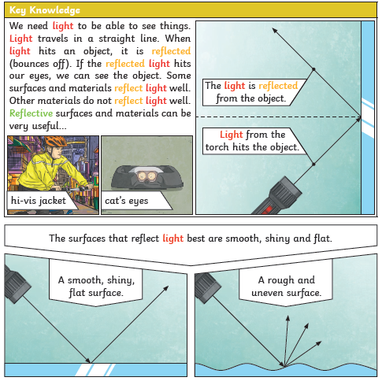
Shadows Protecting your eyes
