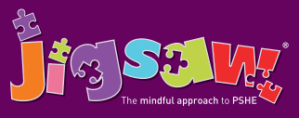
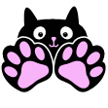
Reception Puzzle 6 Changing Me
Knowledge | Social and Emotional skills
- Know the names and functions of some parts of the body (see vocabulary list)  • Know that we grow from baby to adult  • Know who to talk to if they are feeling worried  • Know that sharing how they feel can help solve a worry  • Know that remembering happy times can help us move on | • Can identify how they have changed from a baby  • Can say what might change for them they get older  • Recognise that changing class can illicit happy and/or sad emotions  • Can say how they feel about changing class/growing up  • Can identify positive memories from the past year in school/ home  • Which parts of your body do you know the same of?  • Who can you talk to if you ever feel worried or  frightened? (at school / at home)
Children are encouraged to think about how they have changed from being a baby and what may change for them in the future. They consolidate the names and functions of some of the main parts of the body and discuss how these have changed. They learn that our bodies change as we get older in lots of different ways. Children understand that change can bring about positive and negative feelings, and that sharing these can help. They also consider the role that memories can have in managing change.

Key Vocabulary:
Eye, Foot, Eyebrow, Forehead, Ear, Mouth, Arm, Leg, Chest, Knee, Nose, Tongue, Finger, Toe, Stomach, Hand, Baby, Grown-up, Adult, Change, Worry, Excited, Memories.

