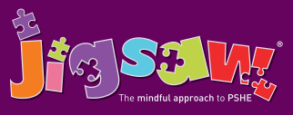
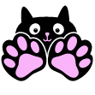
Year 1 Puzzle 6 Changing Me
Knowledge | Social and Emotional skills
- Know that animals including humans have a life cycle  • Know that changes happen when we grow up  • Know that people grow up at different rates and that is normal  • Know the names of male and female private body parts  • Know that there are correct names for private body parts and nicknames, and when to use them  • Know which parts of the body are private and that they belong to that person and that nobody has the right to hurt these  • Know who to ask for help if they are worried or frightened  • Know that learning brings about change | - Understand and accepts that change is a natural part of getting older  • Can identify some things that have changed and some things that have stayed the same since being a baby (including the body)  • Can express why they enjoy learning  • Can suggest ways to manage change e.g. moving to a new class
Children are introduced to life cycles e.g. that of a frog and identify the different stages. They compare this with a human life cycle and look at simple changes from baby to adult e.g. getting taller, learning to walk etc. They discuss how they have changed so far and that people grow up at different rates. As part of a school’s safeguarding duty, pupils are taught the correct words for private parts of the body (those kept private by underwear: vagina, anus, penis, testicles, vulva). They are also taught that nobody has the right to hurt these parts of the body. Change is discussed as a natural and normal part of getting older which can bring about happy and sad feelings. Children practise a range of skills to help manage their feelings and learn how to access help if they are worried about change, or if someone is hurting them.
Key Vocabulary:
Changes, Life cycles, Baby, Adult, Adulthood, Grown-up, Mature, Male, Female, Vagina, Penis, Testicles, Vulva, Anus, Learn, New, Grow, Feelings, Anxious, Worried, Excited, Coping.

