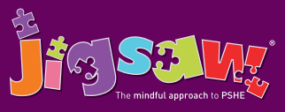
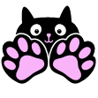
Year 1 Puzzle 4 Healthy Me
Knowledge | Social and Emotional skills
• Know the difference between being healthy and unhealthy  • Know some ways to keep healthy  • Know how to make healthy lifestyle choices  • Know how to keep themselves clean and  healthy  • Know that germs cause disease / illness  • Know that all household products, including medicines, can be harmful if not used properly  • Know that medicines can help them if they feel poorly  • Know how to keep safe when crossing the road  • Know about people who can keep them safe | • Feel good about yourself when you make healthy choices  • Realise that you are special  • Keep yourself safe  • Recognise ways to look after yourself if you feel poorly  • Recognise when you feel frightened and know how to ask for help  • Recognise how being healthy helps you to feel happy
In this Puzzle the class talk healthy and unhealthy choices and how these choices make them feel. They talk about hygiene, keeping themselves clean and that germs can make you unwell. The children learn about road safety as well as people who can help them to stay safe.
Key Vocabulary:
Healthy, Unhealthy, Balanced, Exercise, Sleep, Choices, Clean, Body parts, Keeping clean, Toiletry items (e.g. toothbrush, shampoo, soap), Hygienic, Safe Medicines, Trust, Safe, Safety, Green Cross Code, Eyes, Ears, Look, Listen, Wait.

