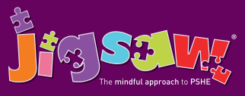
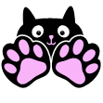
Year 5 Puzzle 1 Being Me in My World
Knowledge | Social and Emotional skills
- Know how to face new challenges positively  - Understand how to set personal goals  - Understand the rights and responsibilities associated with being a citizen in the wider community and their country  - Know how an individual’s behaviour can affect a group and the consequences of this  - Understand how democracy and having a voice benefits the school community  - Understand how to contribute towards the democratic process | - Be able to identify what they value most about school  - Identify hopes for the school year  - Empathy for people whose lives are different from their own  - Consider their own actions and the effect they have on themselves and others  - Be able to work as part of a group, listening and contributing effectively  - Understand why the school community benefits from a Learning Charter  - Be able to help friends make positive choices  - Know how to regulate my emotions
In this Puzzle (unit) the children think and talk about the year ahead, goals they could set for themselves as well as the challenges they may face. They learn and talk about their rights and responsibilities as a member of their class, school, wider community and the country they live in. The children talk about their own behaviour and its impact on a group as well as choices, rewards, consequences and the feelings associated with each. They also talk about democracy, how it benefits the school and how they can contribute towards it. They revisit the Jigsaw Charter and set up their Jigsaw Journals.

Vocabulary:
Goals, Worries, Fears, Value, Welcome, Choice, Ghana, West Africa, Cocoa Plantation, Cocoa Pods, Machete, Rights, Community, Education, Wants, Needs, Maslow, Empathy, Comparison, Opportunities, Education, Choices, Behaviour, Responsibilities, Rewards, Consequences, Empathise, Learning Charter, Obstacles, Cooperation, Collaboration, Legal, Illegal, Lawful, Laws, Participation, Motivation, Democracy, Decision, Proud.

