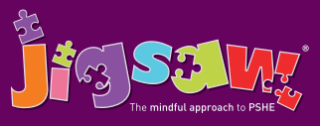
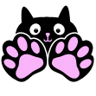
EYFS Puzzle 1 Being Me in My World
Knowledge | Social and Emotional skills
- Know special things about themselves  - Know that some people are different from themselves  - Know how happiness and sadness can be expressed  - Know that hands can be used kindly and unkindly  - Know that being kind is good  - Know they have a right to learn and play, safely and happily | - Identify feelings associated with belonging  - Identify feelings of happiness and sadness  - Skills to play cooperatively with others  - Be able to consider others’ feelings  - Be responsible in the setting
In this Puzzle (unit), the children talk about how they have similarities and differences from their friends and how that is OK. They begin working on recognising and managing their feelings, identifying different ones and the causes these can have. The children talk about working with others and why it is good to be kind and use gentle hands. They discuss children’s rights, especially linked to the right to learn and the right to play. The children talk about what it means to be responsible.

Vocabulary:
Kind, Gentle, Friend, Similar(ity), Different, Rights, Responsibilities, Feelings, Angry, Happy, Excited, Nervous, Sharing, Taking Turns.

