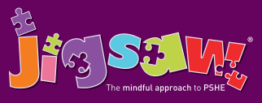
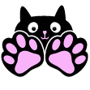
Year 3 Puzzle 1 Being Me in My World
Knowledge | Social and Emotional skills
- Understand that they are important  - Know what a personal goal is  - Understanding what a challenge is  - Know why rules are needed and how these relate to choices and consequences  - Know that actions can affect others’ feelings  - Know that others may hold different views  - Know that the school has a shared set of values | - Recognise self-worth  - Identify personal strengths  - Be able to set a personal goal  - Recognise feelings of happiness, sadness, worry and fear in themselves and others  - Make other people feel valued  - Develop compassion and empathy for others  - Be able to work collaboratively
In this Puzzle (unit) the children learn to recognise their self-worth and identify positive things about themselves and their achievements. They talk about new challenges and how to face them with positivity. The children talk about the need for rules and how these relate to rights and responsibilities. They talk about choices and consequences, working collaboratively and seeing things from other people’s points of view. The children talk about different feelings and the ability to recognise these feelings in themselves and others. They set up their Jigsaw Journals and establish the Jigsaw Charter.

Vocabulary:
Welcome, Valued, Achievements, Proud, Pleased, Personal Goal, Praise, Acknowledge, Affirm, Emotions, Feelings, Nightmare, Fears, Worries, Solutions, Support, Rights, Responsibilities, Learning Charter, Dream, Behaviour, Rewards, Consequences, Actions, Fairness, Choices, Co-Operate, Group Dynamics, Team Work, View Point, Ideal School, Belong.

