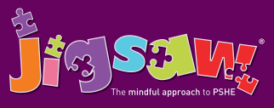
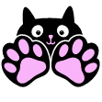
Year 2 Puzzle 1 Being Me in My World
Knowledge | Social and Emotional skills
- Identifying hopes and fears for the year ahead  - Understand the rights and responsibilities of class members  - Know that it is important to listen to other people  - Understand that their own views are valuable  - Know about rewards and consequences and that these stem from choices  - Know that positive choices impact positively on self-learning and the learning of others | - Recognise own feelings and know when and where to get help  - Know how to make their class a safe and fair place  - Show good listening skills  - Recognise the feeling of being worried  - Be able to work cooperatively
In this Puzzle (unit) the children discuss their hopes and fears for the year ahead – they talk about feeling worried and recognising when they should ask for help and who to ask. They talk about rights and responsibilities; how to work collaboratively, how to listen to each other and how to make their classroom a safe and fair place. The children talk about choices and the consequences of making different choices, set up their Jigsaw Journals and make the Jigsaw Charter.

Vocabulary:
Worries, Hopes, Fears, Belonging, Rights, Responsibilities, Responsible, Actions, Praise, Reward, Consequence, Positive, Negative, Choices, Co-Operate, Learning Charter, Problem-Solving.

