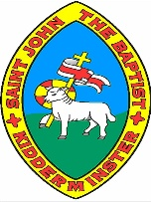
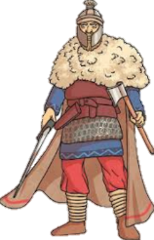
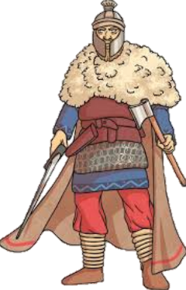
Saxon Settlers Knowledge Organiser

Map of Anglo-Saxon Routes |  |  | Kingdoms, Battles and Life in the Anglo-Saxon Times
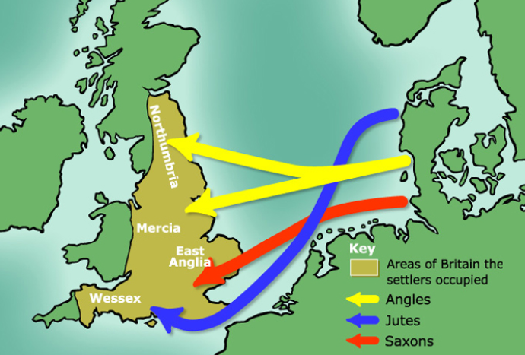  After the Romans left Britain, it became more open to invasion. The Anglo-Saxons were made up of people who rowed across the North Sea from an area that is now northern Germany, Denmark and the Netherlands. These people were from three tribes: the Angles, the Saxons, and the Jutes. The Angles settled in northern England and East Anglia. The Saxons settled in large sections of southern England. The Jutes, meanwhile, adopted areas of Hampshire, Kent, and the Isle of Wight. |  |  | East Anglia | 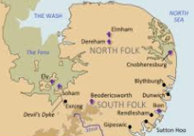 | East Anglia was a small independent kingdom of the Angles, which was formed in the 6th Century in the wake of the Anglo-Saxon settlement of Great Britain. It was incorporated into the Kingdom of England in 918. | Where?  The East of England | Key Fact:  The swampy ‘Fens’ separated much of East Anglia from the other kingdoms.
 |  |  | Mercia | 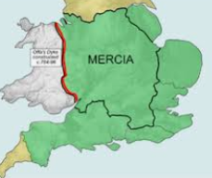 | Mercia was a large Anglo-Saxon kingdom that was centred around the River Trent. For 300 years (between 600 and 900AD) Mercia dominated England south of the River Humber – a period known as the Mercian Supremacy. | Where?  English midlands | Key Fact:  After invasions by the Vikings, much of Mercia was absorbed into Danelaw.
 |  |  | Wessex | 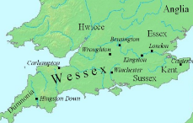 | Wessex was an Anglo-Saxon kingdom in the south of the country. A number of famous Wessex kings have become prominent figures in history, including Alfred the Great and Egbert – the first King of England. | Where?  South and South West-England | Key Fact:  Wessex ceased to exist after King Harold’s defeat in 1066.
 |  |  | Northumbria | 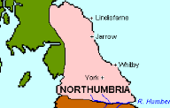 | Northumbria was another medieval Anglican kingdom. It was originally made up of two separate kingdoms – Bernicia (from around Cumbria) and Deira (from around York) – until the two united around the year 654. | Where?  North-eastern England and south-eastern Scotland | Key Fact:  The name Northumbria means ‘the people north of the Humber.’
 |  |  | Danelaw | 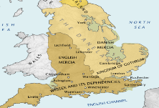 | King Alfred the Great defeated the Vikings in 878 AD, and had them sign a treaty, which governed that the Vikings stick to their own land in north and east England – this section of land became known as the Danelaw. | Where?  North and East England | Key Fact:  The Vikings did not give up on ruling all of England, and eventually did!
Key Vocabulary
Angles – Tribes from modern day Denmark.
Christianity – A religion based on the teachings of Jesus.
Invasion – To try to take over a place by force.
Missionary – A person from a religion sent to spread the faith.
Pagan – A religion that involves worshipping many gods and goddesses.
Picts – Tribes originally from Scotland who were ‘foul’ and had a ‘lust for blood.’
Romans – The Romans invaded and settled in Britain for over 400 years, starting with their first successful raid in 54BC.
Saxons – German – Dutch tribes who settled in Britain from around 450AD.
Settler – People who migrate to a new place. When people start a community, this is a settlement.
Scots – People from Ireland, who, like the Picts were fierce and powerful fighters.

 |  |  | Clothes | 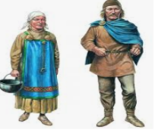 | Men wore long-sleeved tunics made of wool or linen, and these were often decorated with patterns. Women would wear an underdress of linen, and an outer pinafore-like dress called a ‘peplos.’ Shoes were made of leather.  Anglo-Saxon  Timeline | How?  Anglo-Saxons made their clothes from natural resources. | Key Fact:  Belts were used to hang tools and small weapons from.

1066 AD
At the Battle of Hastings, the Normans defeat the Anglo-Saxons.
1016-1035 AD
Canute the Great – the first Viking king - rules
871-899 AD
Alfred the Great rules.
802 AD
Egbert becomes the first King of England.
597 AD
St. Augustine arrives in Britain and introduces people to Christianity.
547-586 AD
The Kingdoms of Northumberland, East Anglia, and Mercia are formed.
477-495 AD
The Kingdoms of Wessex and Essex are formed.
455 AD
The Kingdom of Kent is established (primarily by the Jutes).
410 AD
The Romans leave Britain unguarded.

