Key Vocabulary
UKS2
Maya Civilisation
civilisation | An organised society with its own culture and way of life, existing in a particular area over a particular period of time.
drought | A long period with very little rain.
ritual | A ceremony, often religious, with set actions performed in a set order.
jaguar | A big cat, heavier than a leopard, with yellowish fur and black spots.
scribes | People paid to write things down, either as an official record or for someone else unable to write.
codices | Ancient handwritten texts. Maya codices could be unfolded like a concertina. One text is called a codex.
maize | Another word for sweetcorn or corn on the cob. It can be made into a dough and baked into tortillas.
cacao  beans | Cacao trees sprout pods directly from their trunks. When they are ripe, the pods can be broken open to reveal the beans, which can then be dried, roasted and ground.
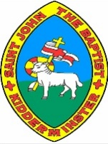
Meet the Maya Knowledge Organiser
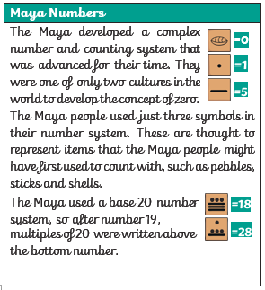
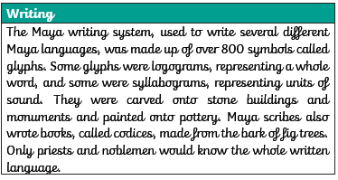
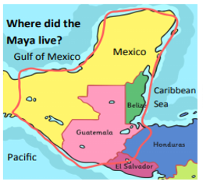

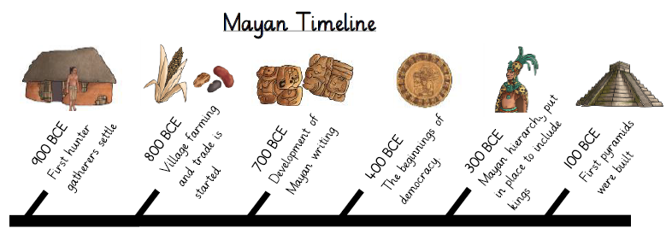
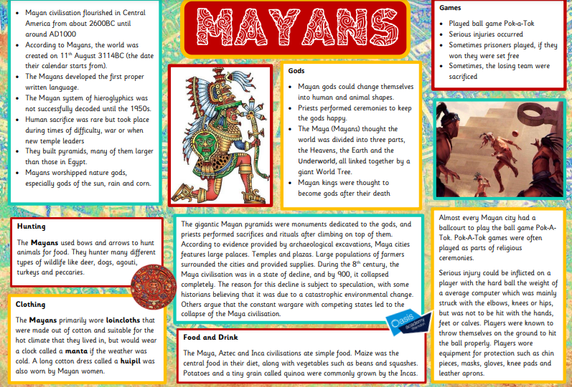
Meet the Maya Knowledge Organiser

