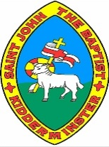
Rule Britannia Knowledge Organiser
King and Queen Facts
Why was William I known as William the Conqueror? | William I came from France. He killed King Harold in the Battle of Hastings in 1066 and took over England, becoming known as ‘William the Conqueror’.
Why was King Edward I known as ‘Longshanks’? | King Edward I was given the nickname ‘Longshanks’ because he was very tall. He was also known as the ‘Hammer of Scots’ as he spend years fighting wards with Scotland
What is Henry VIII known for? | Henry was desperate for a son, so when his wife Katherine of Aragon gave birth to a baby girl, he divorced her. In doing so, he split England from the Catholic Church and created Church of England. Henry had a total of 6 wives. He divorced 2 and beheaded 2!  (Divorced, Beheaded, Died: Divorced, Beheaded, Survived)
Who is the longest reigning monarch? | In 2020, Queen Elizabeth II became the longest reigning monarch with 70 years on the throne! Before this Queen Victoria had been the longest reigning monarch with 64 years!
What is Richard III remembered for? | Richard III is often remembered for being a cruel and unkind king. Some people think he killed his nephews to become king. He is also famous because nobody knew where he was buried until his skeleton was discovered in a car park in 2012
Key Vocabulary
monarch | A king or queen, an emperor or a sultan.
Parliament | This is where politicians meet to decide laws.
succession | This is the order in which a monarch’s family will take over the throne.
abdicate | If a king or queen abdicates, he or she gives up being king or queen
reign | A period of time that a monarch rules over the country.

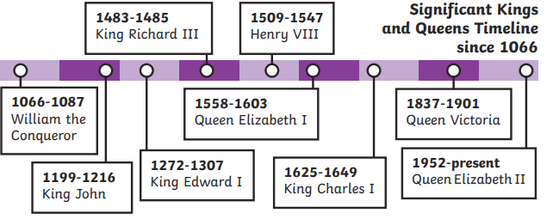
Significant Kings and Queens since 1066

