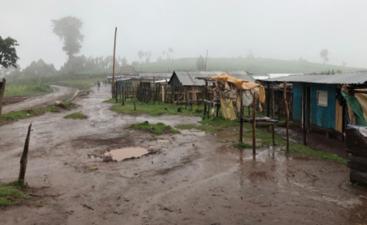
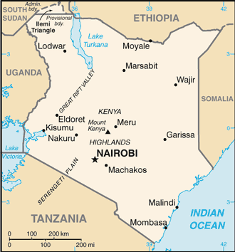
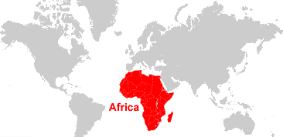
Non-negotiable spellings
Africa
Equator
Human
Physical
Landmark
Tourism
Conservation
Kenya
Madagascar

Year 4: Unit 1- Africa
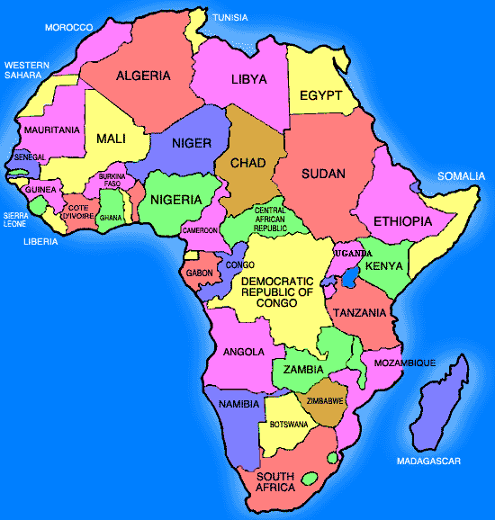
Equator | An imaginary line across the middle of the Earth splitting it into Northern and Southern hemispheres.
Land locked | Entirely surrounded by land.
Surface area | The total area a country occupies.
Landscape | Visible features of an area of land.
Culture | Ideas, traditions and behaviour of a particular type of people or society.
Landmark | An important object or features which is seen from a distance and helps to represent a location.
Poverty | Extreme poorness.
Tourism | Holidays and visits to places of interest.
Human features | Created by people.
Physical features | Natural.
Conservation | To preserve and protect the natural environment and wildlife.

