Border | A line separating two countries
Equator | An imaginary line across the middle of the Earth splitting it into Northern and Southern hemispheres.
Land locked | Entirely surrounded by land.
Coastline | The land or country is situated on the coast (sea or ocean).
Landmark | An important object or features which is seen from a distance and helps to represent a location.
Tourism | Holidays and visits to places of interest.
Human features | Created by people.
Physical features | Natural.
Rural | Relating to the countryside rather than the town.
Urban | Relating to a town or city.
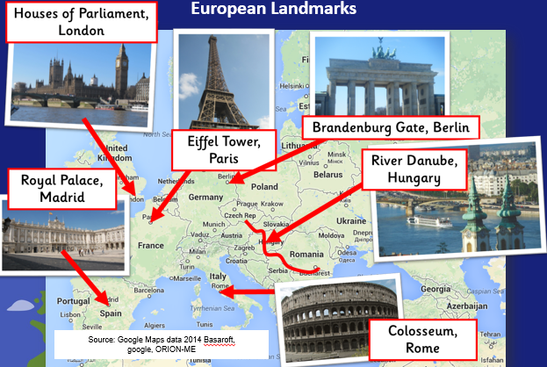
Year 3: Unit 1- Europe

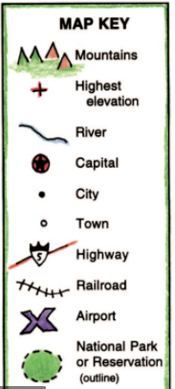
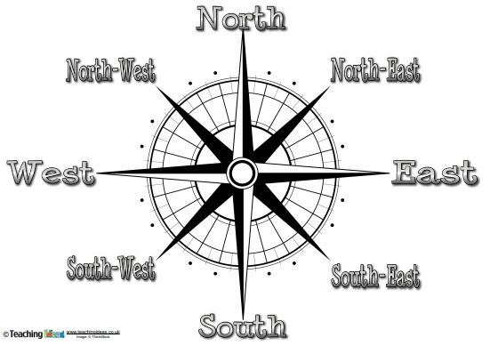
Non-negotiable spellings
Europe
Equator
Country
Continent
Germany
France
United Kingdom
Italy
Spain
Mountain
Landmark
Tourism
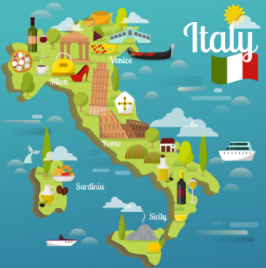
Capital cities
Austria | Vienna
Belgium | Brussels
Denmark | Copenhagen
France | Paris
Germany | Berlin
Greece | Athens
Ireland | Dublin
Italy | Rome
Netherlands (Holland) | Amsterdam
Poland | Warsaw
Portugal | Lisbon
Russia | Moscow
Spain | Madrid
Switzerland | Bern
United Kingdom (England) | London

