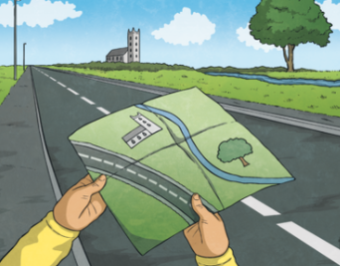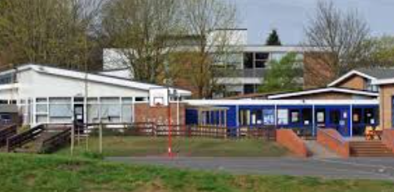

Non-negotiable spellings

**North**

**East**

**South**

**West**

**Environment**

**School**

**Physical**

**Human**

Year 2: Unit 1- Our Local Environment

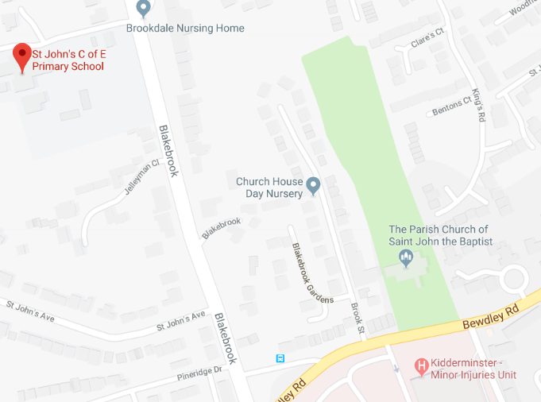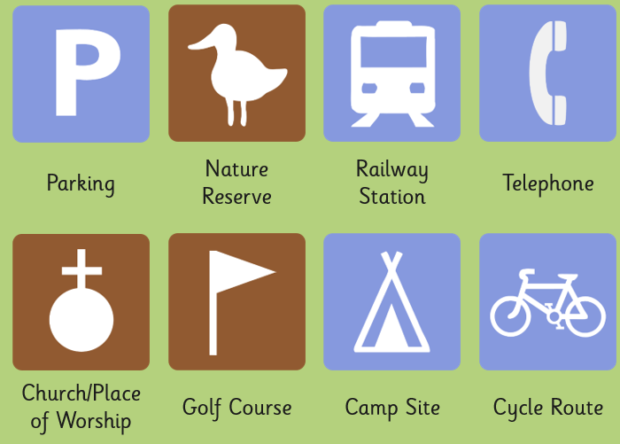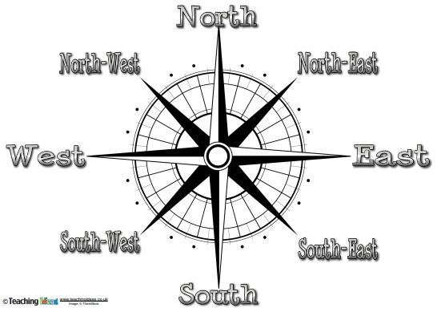

Don’t forget to turn the map so it shows where things are in real life!

|  |  |
| --- | --- |
| Human features | Town  City  Factory  Farm  House  Shop |
| Physical features | Beach  Cliff  Forest  Hill  Mountain  Ocean  River |
| Aerial view/bird’s-eye view | A view from a great height. |

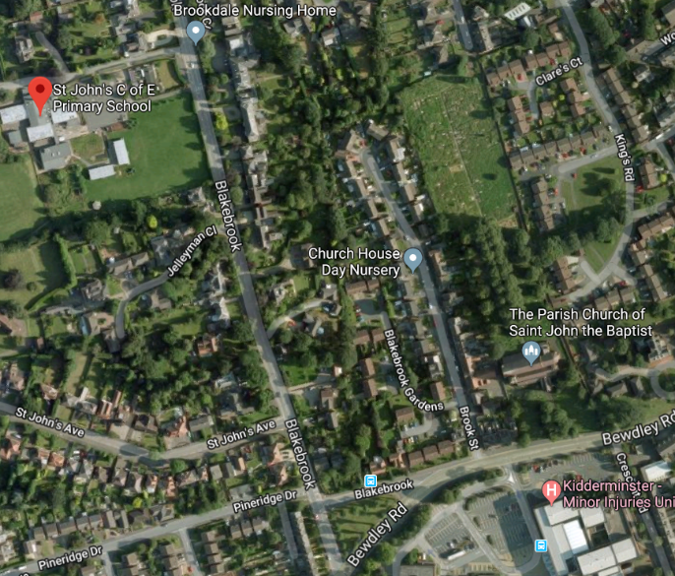

Maps have symbols to help us find important places.

