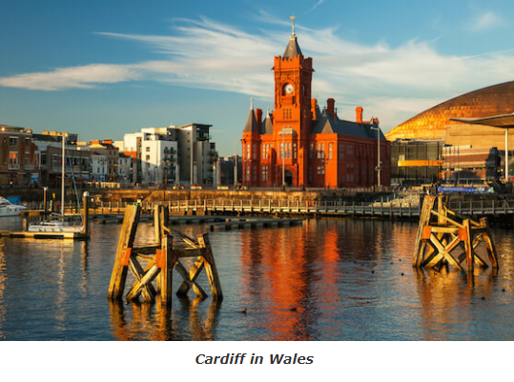

Capital cities of the UK

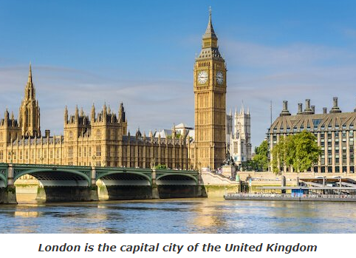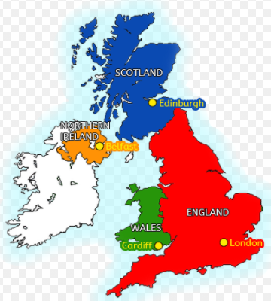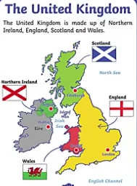

Non-negotiable spellings

**United Kingdom**

**Map**

**England**

**Ireland**

**Scotland**

**Wales**

**Flag**

**Sea**

**Human**

**Physical**

Year 1: Unit 1- The United Kingdom

|  |  |
| --- | --- |
| Human features | Town  City  Factory  Farm  House  Shop |
| Physical features | Beach  Cliff  Forest  Hill  Mountain  Ocean  River |
| Highest Mountain | Ben Nevis in Scotland |
| Longest River | River Severn |

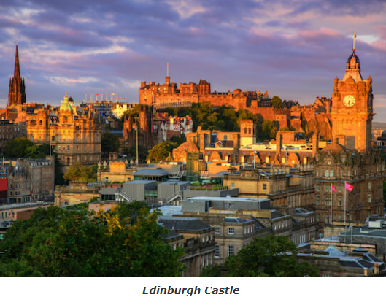

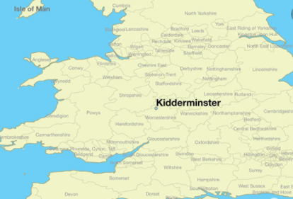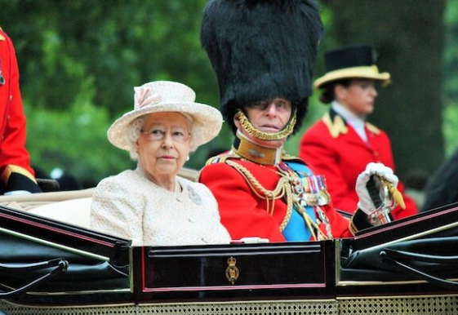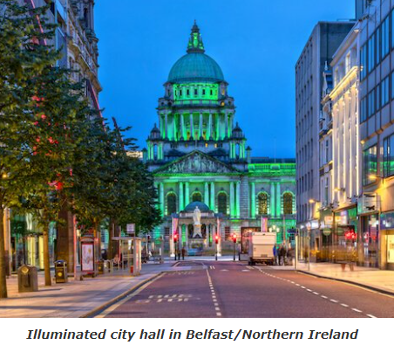

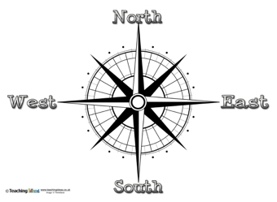

Queen Elizabeth II and Prince Phillip