**Key Knowledge for the unit:**

1. Start blocks are used to run your programs.
2. Programming blocks are used to give instructions to each of the sprites.
3. Blocks can be joined together to make a sequence.
4. Blocks can be chosen to fulfil a specific purpose.
5. Using different blocks can alter the outcome.
6. Extensions can be used for extra tools such as the pen.
7. Loops can be created to save code and the number of blocks.
8. If a condition is met, then an action will take place.

**Useful diagrams for the unit:**

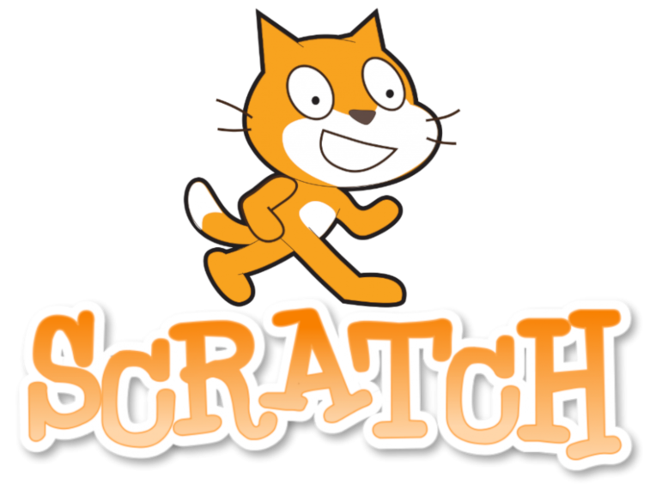

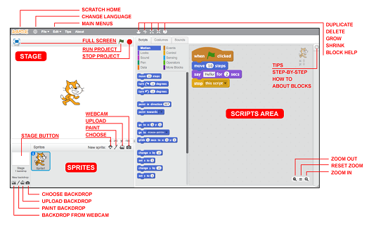

**Key Vocabulary for the unit:**

Algorithms – instructions that are split into little steps.

Conditions – statements that are created by the programmer which evaluates actions in the program and evaluates if it's true or false.

Debugging – process of detecting and removing of existing and potential errors.

Duplicating – make or be an exact copy of.

Event – something that happens.

Infinite loop - a sequence of instructions in a computer program which loops endlessly.

Modifying – make partial or minor changes to something.

Program – steps of instructions for a computer.

Repetition – the process of looping or repeating sections of a computer program.

Selection – a section of code is run only if a condition is met.

Sprite – a character or object that you can code.

Year 5 – Selection in Quizzes