**Key Knowledge for the unit:**

1. All photos aren’t real.
2. Know what you want to do before you start to change anything.
3. Change an image small steps at a time – you can always undo.
4. Make sure you are allowed to use the images before you use them in your own work.

**Useful diagrams for the unit:**





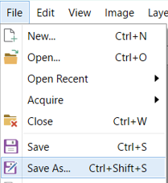

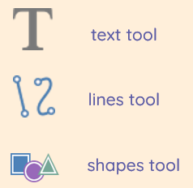

**Key Vocabulary for the unit:**

Adjustments – a small alteration or movement made to achieve a desired fit, appearance, or result.

Clone – replicates pixels from within an image.

Composition – the way that something is put together or arranged

Crop – to cut off the sides of an image to make it the proper size or to remove unwanted parts.

Edit – to make a change to something.

Effects – different ways to change an image.

Image – a visual representation of something

Retouch – improve or repair an image by making slight additions or alterations.

Year 4 – Photo Editing