**Key Knowledge for the unit:**

1. Know the audience for your task.
2. Know how you want it to look.
3. Don’t rush any decisions.
4. Nothing is final – you can edit your work.
5. Make sure the font is clear.
6. Make sure the colours work together.
7. Make sure the work isn’t too crowded.

**Useful diagrams for the unit:**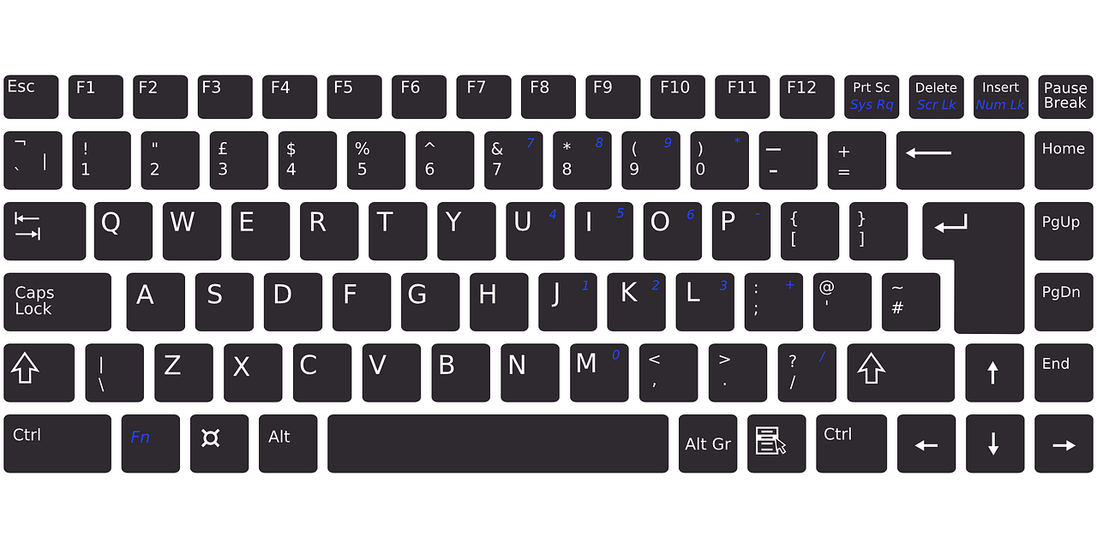

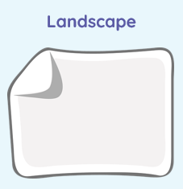 

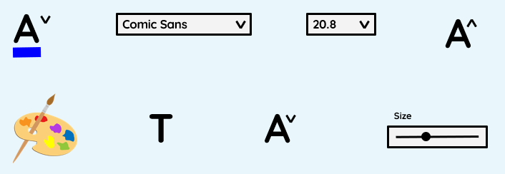

**Key Vocabulary for the unit:**

Content – the information included

Font – is a style of text

Images – the pictures on a page

Layout – how information is presented

Page orientation – to choose whether to have your page landscape or portrait.

Place holders – the boxes that hold the place of the text or images that you are going to add to your document.

Template – is a document that has already been laid out in a certain way.

Text – the words on a page

Year 3 – Desktop Publishing