**Key Knowledge for the unit:**

1. Your questions must be able to be answered with a yes or no.
2. Your questions must be simple.
3. Make sure your questions can’t be interpreted in a different way.

**Useful diagrams for the unit:**



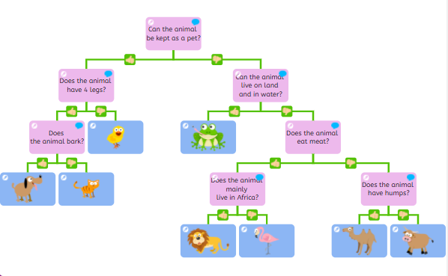









**Key Vocabulary for the unit:**

Attribute – a piece of information which determines the properties of a field or tag in a database or a string of characters in a display.

Branching database – A branching database (sometimes called a binary tree) is a way of classifying a group of objects.

Properties - a quality or trait belonging and especially peculiar to an individual or thing.

Tree structure – A tree structure is an algorithm for placing and locating files (called records or keys) in a database.

Year 4 – Data Logging