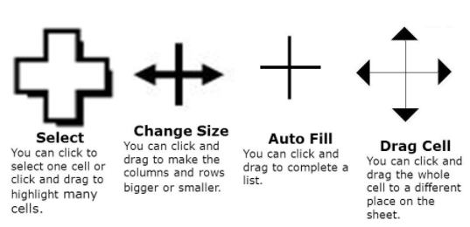

Column

Cell

Format bar

Row

**Key Knowledge for the unit:**

1. ‘Along the corridor, up/down the stairs’.
2. Cell is one single box.
3. Columns are the down cells.
4. Rows are the across cells.
5. Formulas need to be accurate.
6. Formatting needs to be clear.
7. Formulas can be ‘dragged down’ to save time.

**Useful diagrams for the unit:**

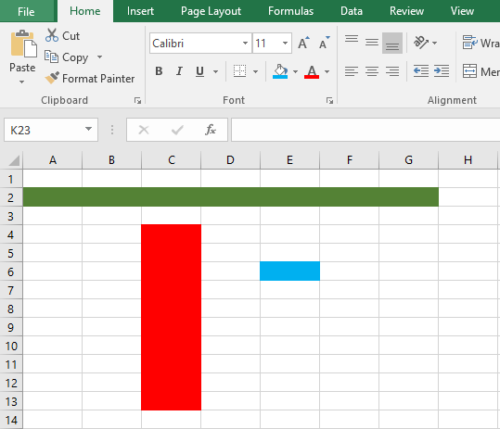

**Key Vocabulary for the unit:**

Cell - Every worksheet is made up of thousands of rectangles, which are called cells. A cell is the intersection of a row and a column.

Column - is a vertical series of cells in a chart, table, or spreadsheet.

Data - facts and statistics collected together for reference or analysis.

Format – formatting cells changes the appearance of a number without changing the number itself.

Formula - is an expression that operates on values in a range of cells or a cell. For example, =A1+A2+A3, which finds the sum of the range of values from cell A1 to cell A3.

Row – is a horizontal series of cells in a chart, table, or spreadsheet.

Spreadsheet - an electronic document in which data is arranged in the rows and columns of a grid and can be manipulated and used in calculations.

Year 6 – Spreadsheets