**Key Knowledge for the unit:**

1. Logo is a computer language which is text-based.
2. The turtle will only move when it recognises the commands inputted.
3. Basic commands (X is represented by a number):
   1. Forward X OR fd X = moves forward
   2. Back X OR bk X = moves back
   3. Left X OR lt X = moves left
   4. Right X OR rt X = moves right
   5. Clearscreen OR cs = clears the screen
   6. Penup OR pu = pen up
   7. Pendown OR pd = pen down

**Useful diagrams for the unit:**

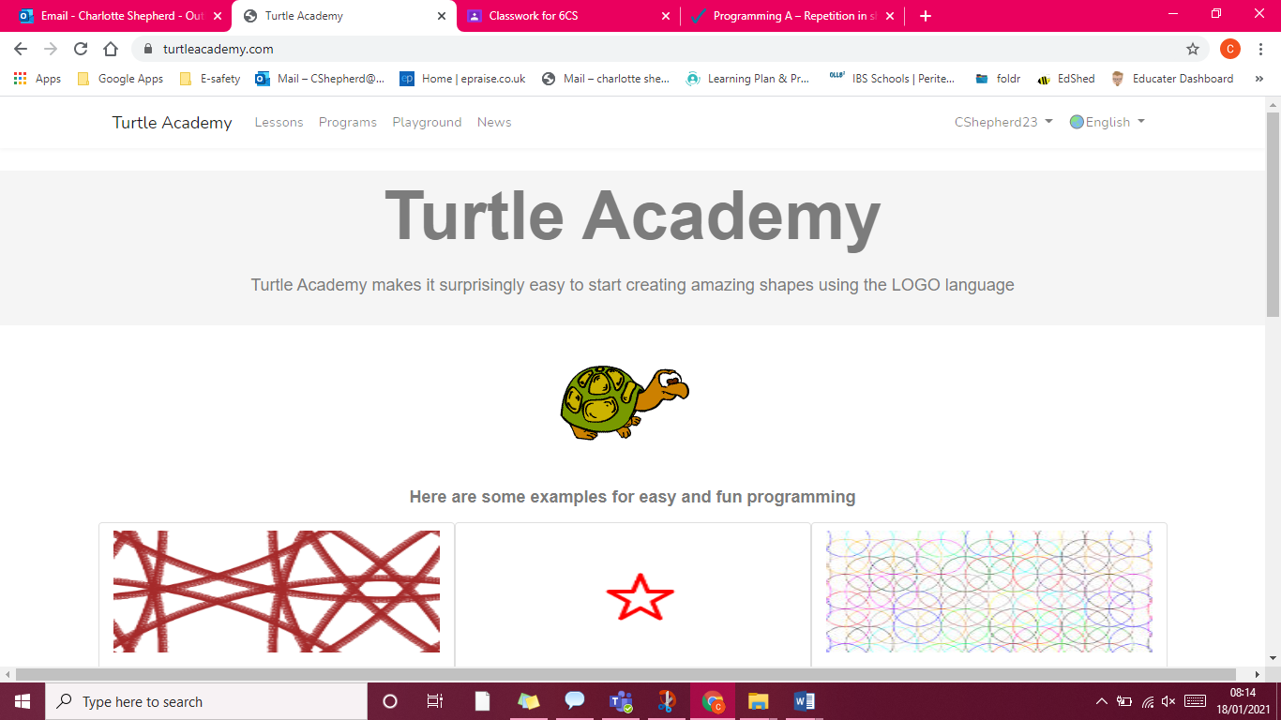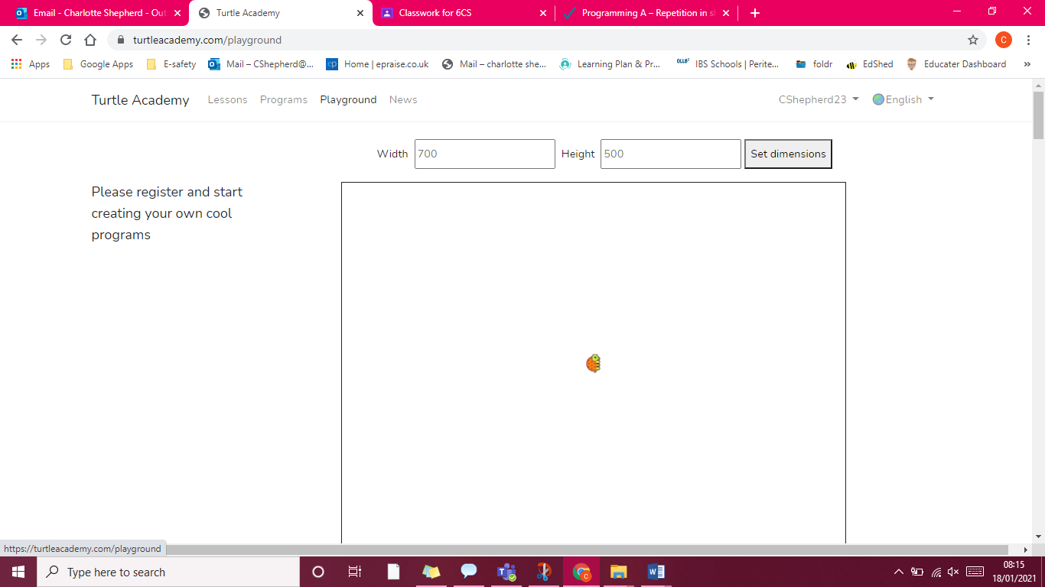

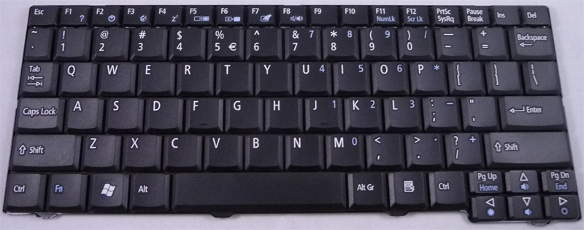

**Key Vocabulary for the unit:**

Algorithm – Steps to follow to achieve a task.

Command – Tell something to a computer program to perform a specific task.

Debugging - To detect and correct the errors in a computer program.

Decomposition – Splitting things into smaller parts.

Logical reasoning – Using rules to solve problems.

Logo - Text-based programming language.

Predict - Estimate what might happen.

Program – Instructions written in a language (code) computers can understand.

Repetition – A programming construct in which one or more instructions are repeated, perhaps a certain number of times, until a condition is satisfied or until the program is stopped.

Sequence – A set of instructions that are followed in order.

Year 4 – Repetition in Shapes