**Key Knowledge for the unit:**

1. Crumble controller is the pad which connects everything.
2. Crumble kits are very similar to your electricity unit in science.
3. LEDs are lights.
4. Conditions can change an algorithm temporarily.
5. Crumble kits need working on and then debugging.

**Useful diagrams for the unit:**

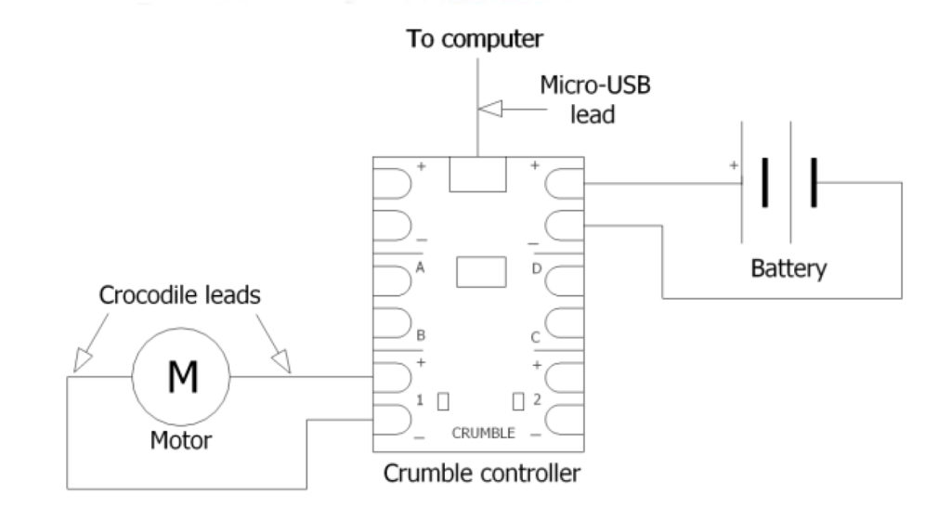

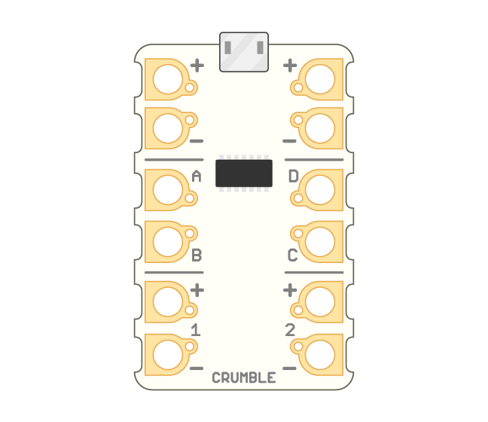

**Key Vocabulary for the unit:**

Algorithm – Steps to follow to achieve a task.

Debugging - To detect and correct the errors in a computer program.

Decomposition – Splitting things into smaller parts.

Input - a piece of equipment used to provide data and control signals to an information processing system such as a computer.

Logical reasoning – Using rules to solve problems.

Output - any piece of computer hardware equipment which converts information into human-readable form.

Predict - Estimate what might happen.

Program – Instructions written in a language (code) computers can understand.

Repetition – A programming construct in which one or more instructions are repeated, perhaps a certain number of times, until a condition is satisfied or until the program is stopped.

Sequence – A set of instructions that are followed in order.

Year 5 – Selection in Physical Computing