**Key Knowledge for the unit:**

1. Type **video editor** into the Search bar and select **Video Editor** to launch the app. Select new video project.
2. Select **Text**, type a title or phrase, then select a style and layout.
3. Select **Custom audio** to add and time your own music tracks, narration, or sound effects.
4. Use **Filters**to change your video clip or photo to black & white or other visual treatments.
5. Select **Motion**to give photos more visual interest.
6. Select **Speed**to speed up or slow down a video clip.
7. If you want to change the orientation of a photo or video, just select the **Rotate**icon.
8. Select **Finish video** to publish your film.
9. **Duplicate project** to copy your video.

**Useful diagrams for the unit:**

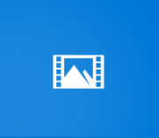

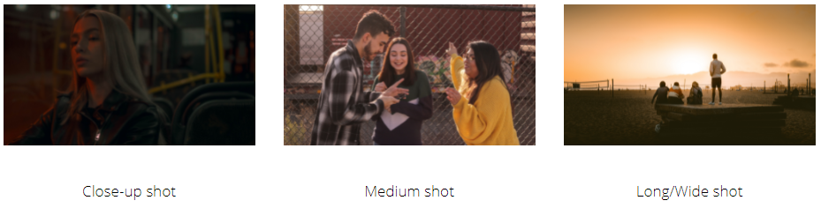

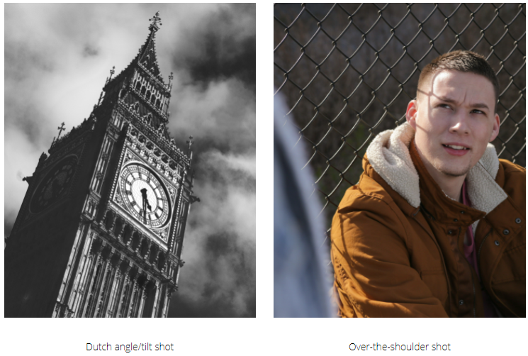

 

**Key Vocabulary for the unit:**

Broadcasting – the distribution of audio or video content to an audience.

Camera angle – the specific location at which the movie camera or video camera is placed to take a shot.

Capture – digital representation of an image.

Export – to convert a file into another format than the one it is currently in.

Filming techniques – ways in how a scene is put together to produce an image.

Production – the process by which a film is made.

Recording – the action or process of recording sound or a performance for subsequent reproduction or broadcast.

Reproducing – produce a copy of.

Video content – any content format that features or includes video.

Year 5 – Video Editing