**Key Knowledge for the unit:**

1. Animations are a series of still images stitched together to create a motion video.
2. Animations can be created using on-screen or off-screen (flipbooks) images.
3. To take an image, press the button that says ‘capture’.
4. Onion skinning takes time and needs to be completed precisely.

**Useful diagrams for the unit:**



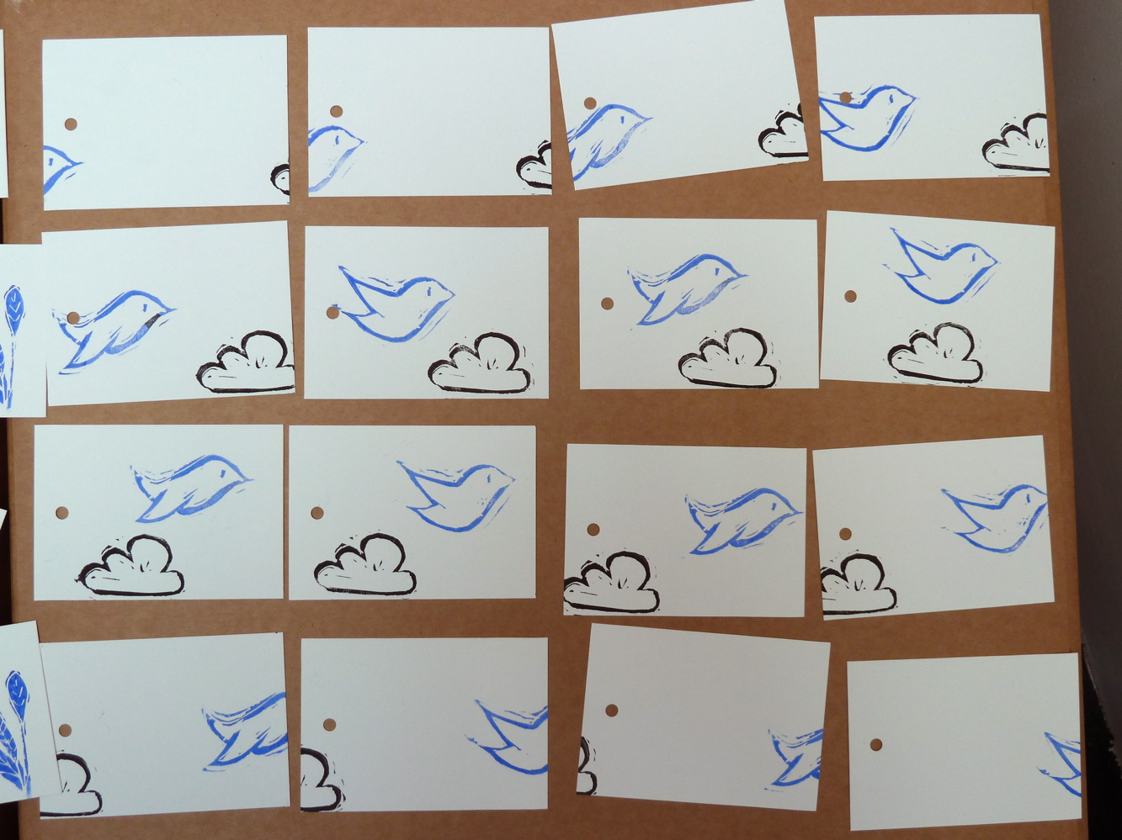

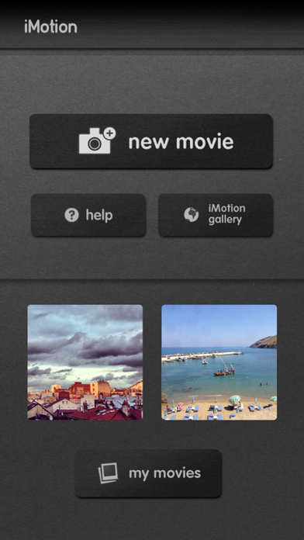

**Key Vocabulary for the unit:**

Animation – process of giving the illusion of movement to drawings, models, or inanimate objects.

Effects – a way to change your image to add an artistic look.

Frame – individual pictures in a sequence of images.

Media – digital files such as music, photographs and texts.

Onion skinning – showing a part transparent photo to demonstrate the previous frame to make small movements more consistent.

Sequence – the order in which something happens.

Year 3 – Stop-frame Animation