**Key Knowledge for the unit:**

1. The white round circle is the button to capture the picture.
2. Landscape is ‘sideways’.
3. Portrait is ‘up’.
4. Pictures can be digitally changed.

**Useful diagrams for the unit:**



 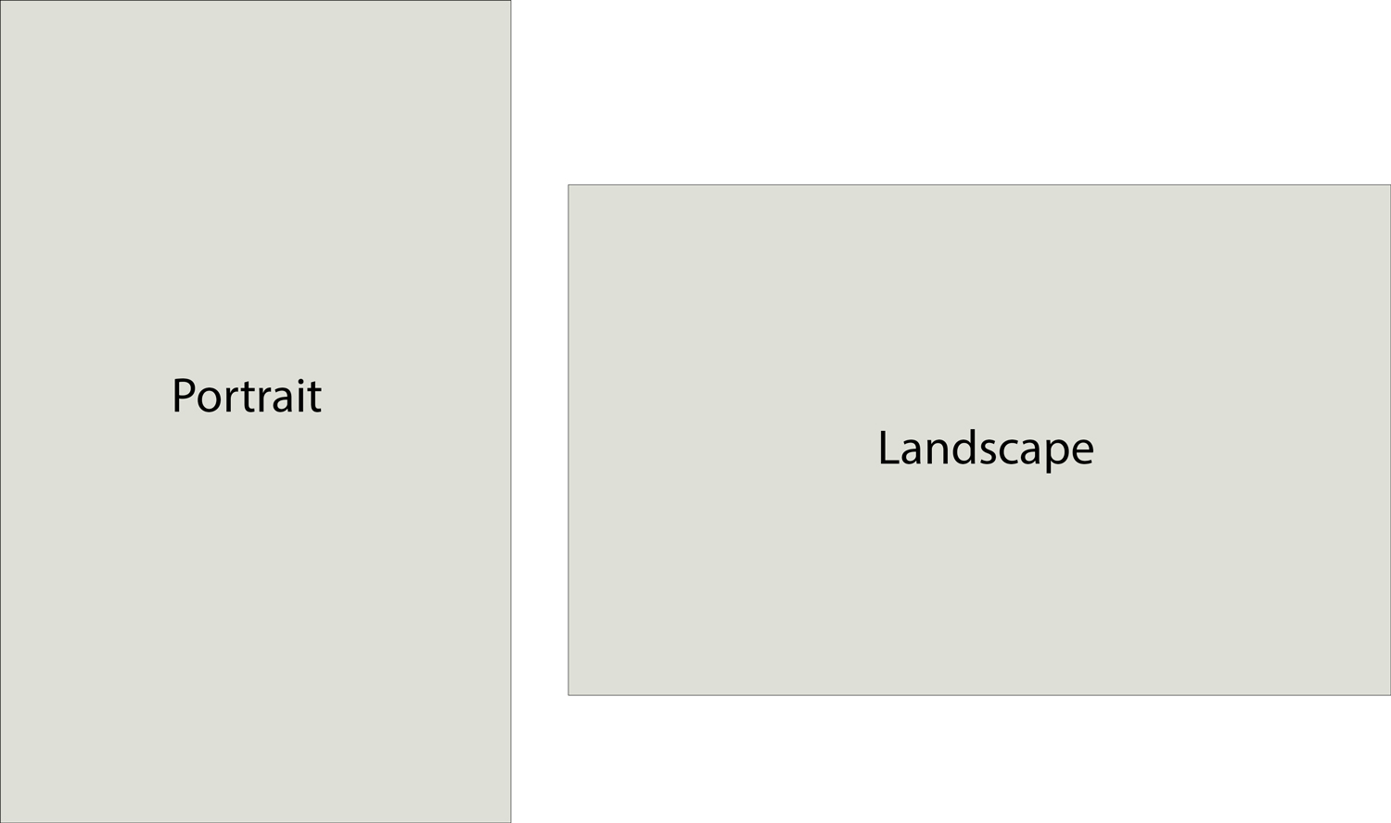

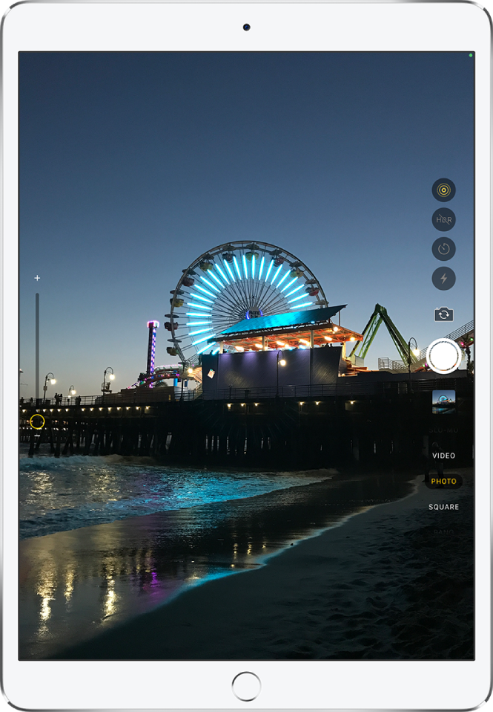

**Key Vocabulary for the unit:**

Adjust – to alter or move something to achieve a desired appearance or result.

Camera autofocus tool – feature of a camera that tries to ensure that your chosen subject is sharp within the photo.

Capture – digital representation of an image.

Edit – alter an image.

Landscape – horizontal orientation in which the long sides of the rectangle are at the top and the bottom.

Portrait – portrait orientation in which the long sides of the rectangle are at the left and the right.

Year 2 – Digital Photography