**Key Knowledge for the unit:**

1. It is easier to create a painting using a mouse rather than the trackpad.
2. Mistakes are easy to undo – have a go.
3. The right mouse button needs to be pressed to select and drag for shapes and tools.
4. Use the ‘edit colours’ box to see more colours to use.

**Useful diagrams for the unit:**

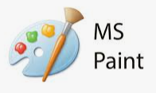

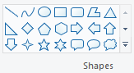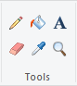

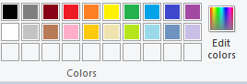

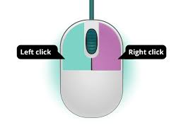

**Key Vocabulary for the unit:**

Brush – change the draw tool to a variety of different tools such as pencil, paintbrush and pen.

Colour – change the colour of the text, shapes, lines and other tools.

Lines – draw straight lines accurately.

Shape – draw shapes easily from a square to a star.

Tools – used to create simple to detailed drawings. Tools include draw, erase, fill, eyedropper, text and magnifier.

Year 1 – Digital Painting