**Key Knowledge for the unit:**

1. To close your word processor use the x in the top right corner.
2. Click ‘Save...’ if it asks you to save!
3. Remember to log off correctly.
4. Click the left button on the mouse at the same time as moving the mouse to drag and select the text.
5. Use both hands to type
6. Caps lock turns capital letters on or off
7. If you are unsure of anything when you are on a computer, always ask a reliable adult for help.
8. Technology is used outside the classroom as well as inside the classroom.

**Useful diagrams for the unit:**

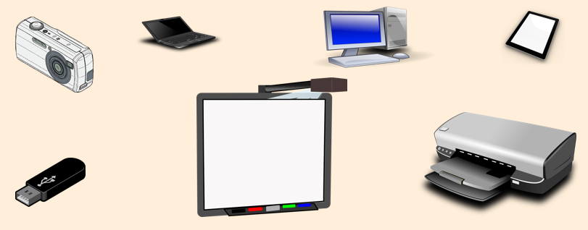

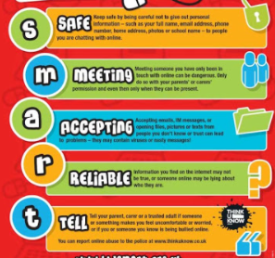

**Key Vocabulary for the unit:**

Computer – an electronic device for working with information.

File – a resource for storing information

Icon – a graphic symbol on a computer display screen that represents an app, an object (such as a file), or a function (such as the command to save)

Information technology – is a term that encompasses all forms of technology used to create, store, exchange, and use information in its various forms

Keyboard – allows a person to enter letters, numbers, and other symbols (these are called characters) into a computer.

Mouse – a small movable device that is connected to a computer

SMART rules – Our online safety rules. Smart, Meet, Accepting, Reliable, Tell.

Technology – is anything made by people to help us

Type – to write something or enter data into a computer by way of a keyboard

Year 2 – IT Around Us