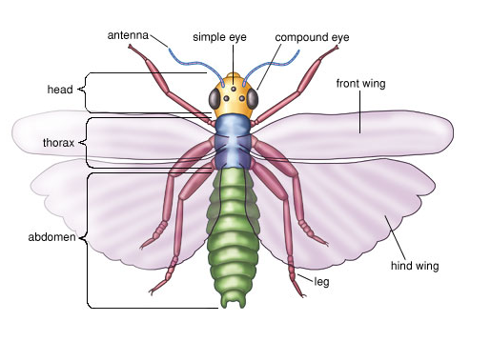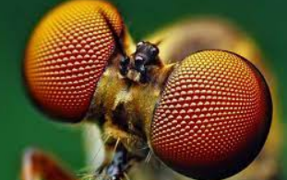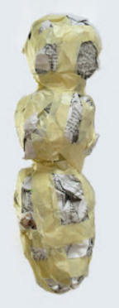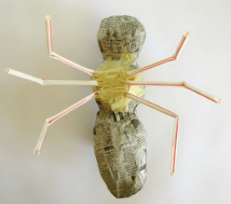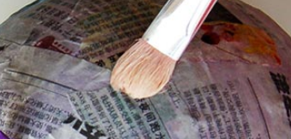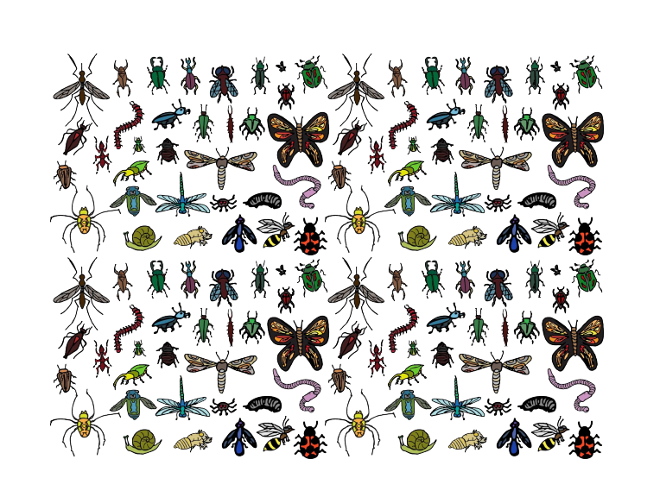

**Key vocabulary**

Pattern – a repeated design

Detail – The smaller parts of a picture or  
item e.g. the detail on the insect’s eyes.

Texture – what things are made from.

Shaping – moulding the newspaper into the correct shape for the insect’s body and head

Joining – attaching other pieces of the body  
using tape

Smoothing – using PVA glue, hands or a brush to make sure there are no lumps in the newspaper

**Key skills**

1. Use joining techniques to join head and body parts
2. Use smoothing techniques to ensure insect is even
3. Be able to use smaller pieces of material to join and smooth
4. Add detail using pieces of material
5. Paint using correctly mixed colours

**Key knowledge**

* Know how to shape (mould) newspaper using hand and tape
* Understand how to attach other pieces e.g. legs to the body
* Know what paper mache is and how it can be used
* Know how to add detail and secure this using paper mache

Year 3 – form