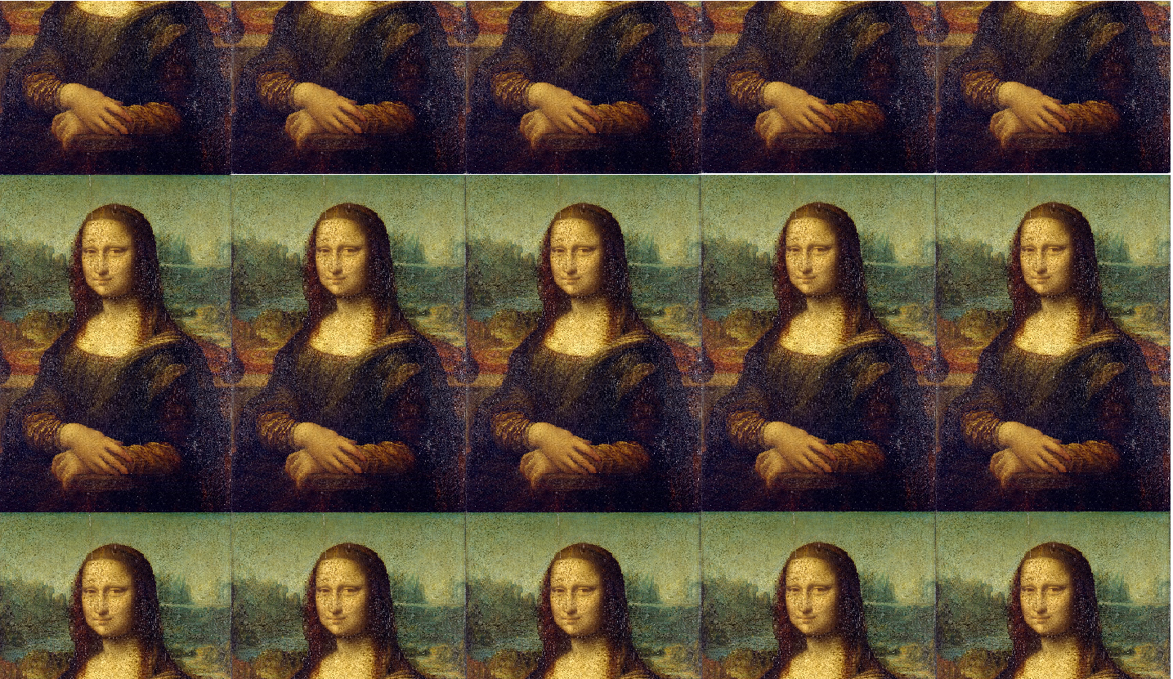

**Key vocabulary**

Proportion – The size and positon of one thing in relation to another.

E.g. How big your head is compared to your body and how this looks when you draw.

Renaissance - The name 'renaissance' is a French word translating to rebirth. It means the beginning of a new period of art.

H – Means it is a hard pencil

B – Means it is a black pencil and softer

HB – Means it is a medium strength pencil

Sketch – A drawing where you use the pencil lightly, do the outline first and then add in detail.

Shading – Making parts of a drawing lighter or darker using lines or a block of colour.

**Key knowledge**

* To know who Da Vinci is and how he contributed to the Renaissance.
* To know what proportion means and how this links to drawing a face.
* Know the different types of pencils and how to choose the right pencil for the task.
* Understand the different steps to be able to draw a face.

**Leonardo da Vinci**

Leonardo da Vinci was an artist, scientist and inventor who lived in Italy. He was born in 1452 and died in 1519.

This time period in Europe is known as the Renaissance. It was a time when many advances were made in education, science, art, literature and music.

The Mona Lisa may be da Vinci's most famous painting. It is on display in the Louvre Museum in France. Some consider it to be the best known and most visited work of art in the world.

**Key skills**

1. Be able to sketch

* Use the pencil lightly
* Draw the outside first
* Add in detail afterwards

1. Be able to draw using proportion.

* Section the drawing
* Understand the size difference in parts of the face and the distance between them.

1. Be able to shade by selecting  
   the correct type of pencil.

Year 3 – drawing