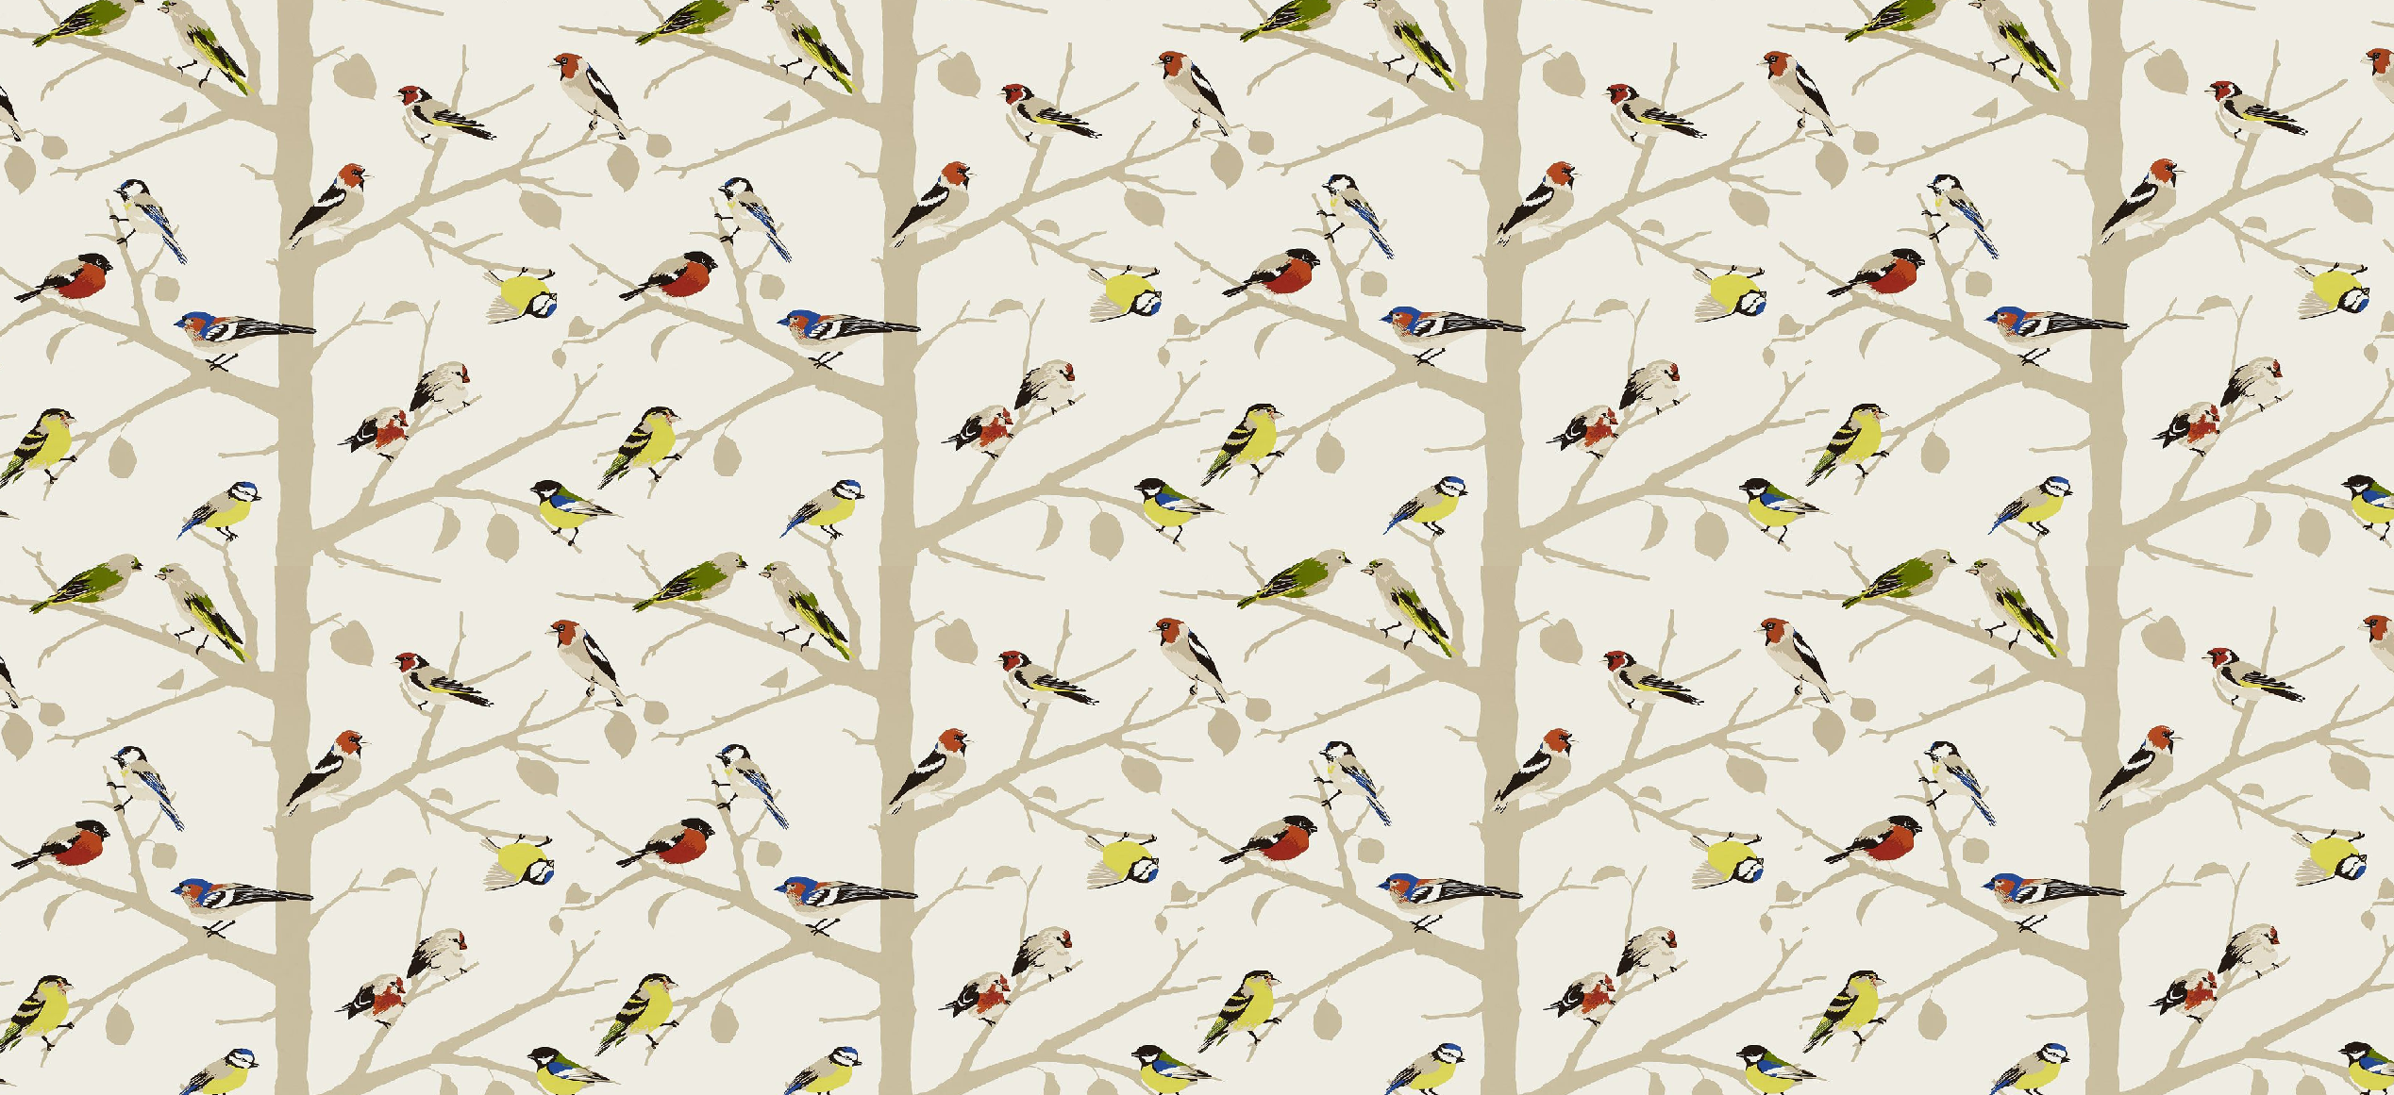

**Key skills**

1. Use different joining techniques e.g. joining head to body and cross hatch for wings
2. Use a variety of different tools to carve in detail
3. Shape using fingers to give detail
4. Paint using primary and secondary colours
5. Mix the primary colours to make secondary colours.

Year 6 – drawing

**Key knowledge**

* To understand and describe the term ‘sculpture’
* Understand and know how to use joining, shaping, carving and modelling techniques.
* Know how to mix primary colours to make secondary colours.

**What is sculpture?**

Sculpture is the branch of the visual arts that operates in three dimensions. It is one of the plastic arts. Durable sculptural processes originally used carving and modelling, in stone, metal, ceramics, wood and other materials but, since Modernism, there has been an almost complete freedom of materials and process.

**Key vocabulary**

Texture – the way something looks or feels.

Pattern – a repeated decorative design.

Joining – attaching two pieces of material

Shaping – changing the shape of a piece of material using tools or hands.

Carving – scraping away material to make a different shape

Modelling – working a soft material usually with hands.

Primary – Red, yellow and blue

Secondary – The colours you get when you mix two of the primary colours together.