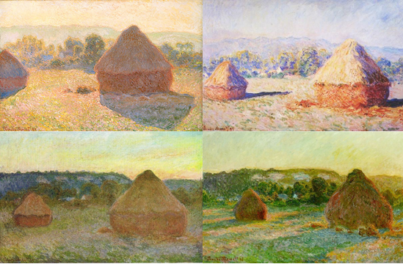T

**Claude Monet**

Monet was one of the first **Impressionist** painters.

Monet often painted the same scene many times, to capture the changing light and seasons.

Monet moved to Giverny in France, and he spent many hours painting the water lilies and the bridge in a series of huge paintings. Paintings of the water lilies are displayed in a curved room in Paris.

Claude Monet developed problems with his sight. This affected the colours used in his paintings.

**Key vocabulary**

Oil paints – a slow drying paint made with oil.

Experimented – trying and investigating something.

Impressionism – a style of painting where colour, light and strong brush strokes were used.

Inspiration – a feeling of enthusiasm you get that helps you be creative.

Realistic – where something looks real

Landscape – is an area of land.

**Key skills**

1. Be able to sketch

* Use the pencil lightly
* Draw the outside first
* Add in detail afterwards

1. Be able to create a shadow using light sources.
2. Experiment with shading by using different tools.
3. Show your feelings through your work and be able to express yourself through art.
4. To be able to discuss Monet’s work.

**Key knowledge**

* To understand what a shadow is and how it is formed.
* To understand how to change a shadow. What makes them longer or shorter?
* To know how Monet expressed his feelings through his art.
* To understand our own feelings.

Year 2 – drawing