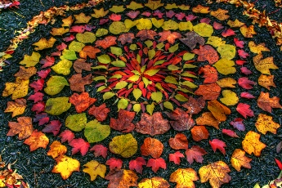

**Key skills**

1. Be able to sketch

* Use the pencil lightly
* Draw the outside first
* Add in detail afterwards

1. Be able to sketch using pattern
2. Be able to carve using pattern
3. Use the carved pieces to create a print
4. Build a print into a picture.

**Owen Young Mortensen**

Owen never lost his childhood fascination with artefacts of nature. He is constantly collecting tumbleweeds, antlers, skulls, stones, and leaves and regards them as treasures. He is also compelled to design and create. It is in the union of these two interests where he finds the most joy.

Born and raised in northern Utah, Owen's work is rooted in the raw elements of nature and the culture as experienced in the high-mountain desert of his home.

Year 4 – printing

**Key knowledge**

* Be able to explain what a pattern is and recognise pattern in objects.
* Understand what man-made pattern is and be able to give examples.
* Understand what natural pattern is and be able to give examples.
* Know how to create a print and identify the skills involved.
* Know how to create a sketch and identify the skills involved.

**Key vocabulary**

Pattern – A repeated decorative design.

Natural – Something that is made naturally not made by humans e.g. trees

Man-made – Made by humans e.g. buildings

Printing –making images that can be transferred onto other surfaces. It can be used to make one or more identical images or to create repeating patterns on papers and textiles

Sketch – A drawing where you use the pencil lightly, do the outline first and then add in detail.