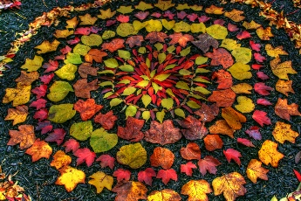

**Key vocabulary**

Pattern – A repeated decorative design.



Natural – Something that is made naturally not made by humans e.g. trees

Man-made – Made by humans e.g. buildings

Printing – moving images onto different places using one object.

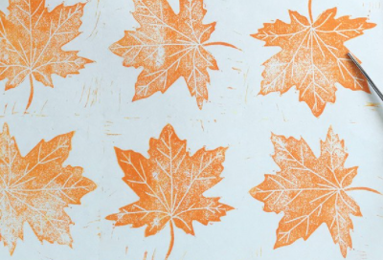

**Owen Young Mortensen**

Owen never lost his childhood fascination with artefacts of nature. He is constantly collecting tumbleweeds, antlers, skulls, stones, and leaves and regards them as treasures. He is also compelled to design and create. It is in the union of these two interests where he finds the most joy.

Born and raised in northern Utah, Owen's work is rooted in the raw elements of nature and the culture as experienced in the high-mountain desert of his home.

**Key skills**

1. Mix primary colours to make secondary and tertiary colours
2. To be able to change the shade of a colour by adding black or white
3. To be able to change the shade by adding blue or yellow
4. Print with a growing range of objects
5. Use tools to create a block print
6. Explain the difference between man-made and natural pattern

**Key knowledge**

* To know the names of the primary and secondary colours.
* To know how to mix colours.
* To know what adding black, white, blue and yellow do to a colour.
* To know what a block print is and how to make one.

Year 2 – painting and printing