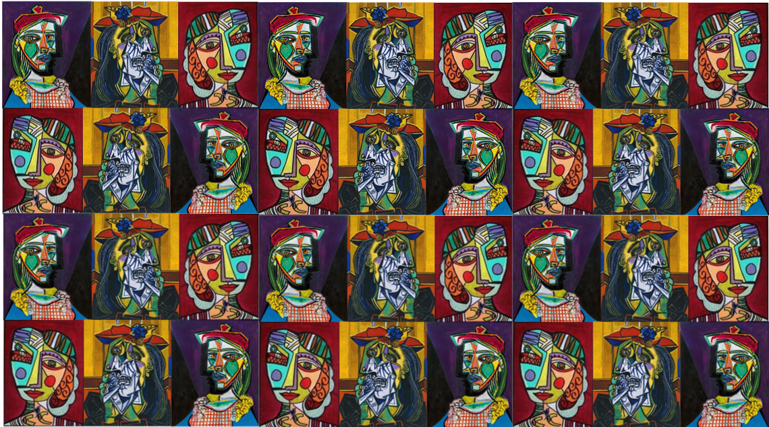

**Key skills**

1. Use hue, tint, tone, shades and mood in my work
2. Explore the use of texture in colour in my own and other peoples work
3. Use colour for purposes and use colour to express feelings
4. Produce increasingly accurate drawings of people concentrating on faces
5. Understand the concept of perspective and proportion and can manipulate these to create an image
6. Create a sketch

Year 6 – drawing and painting

**Key knowledge**

* I understand that a sketch is an initial drawing and the techniques used to create a sketch.
* I understand the terms hue, tint, tone, shade and mood
* I know what proportion is and how to manipulate this
* I know the steps to take to create an accurate sketch of a face

**Picasso**

When Picasso was 16, he left home to attend the best Art School in Spain, the Royal Academy of San Fernando in Madrid. When he was 19, Picasso moved to Paris. There his art began to be noticed.

Along with an artist called Georges Braque, Picasso started a new style of art called Cubism.

Cubism is a style of art which aims to show objects and people from lots of different angles all at one time. This is done using cubes and other shapes. Here are some examples of Picasso’s cubist paintings.

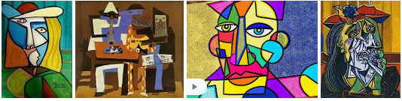

**Key vocabulary**

**Mood** – the atmosphere or feeling in a picture.

**Proportion** – how different parts of an image relate to each other

**Perspective** - making an image look 3D

