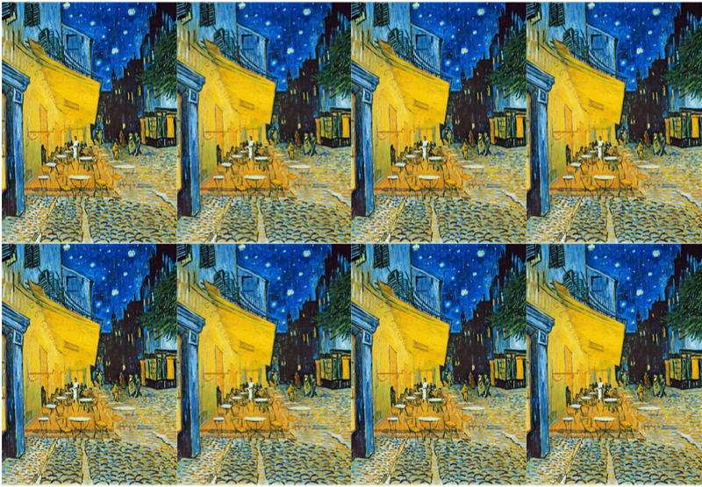

**Key vocabulary**

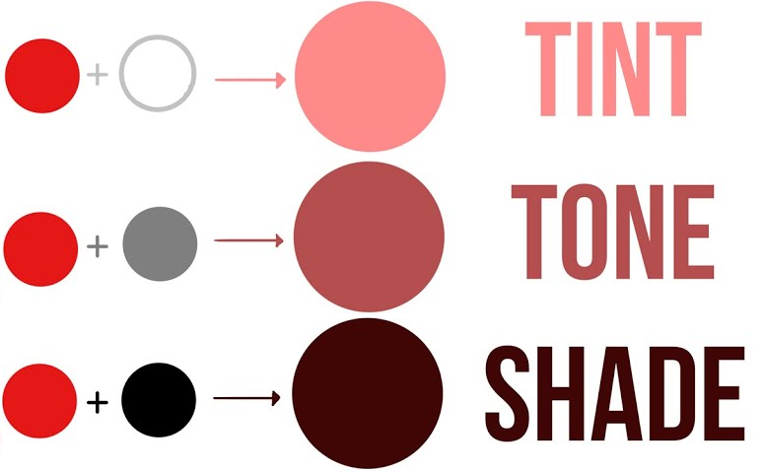

**Scale** – the size of objects in the artwork

**Proportion** – how different parts of an image relate to each other

**Sketch** – a light, first drawing with very little detail.

**Perspective** – making an image look 3D

**3D**

**Key skills**

1. Change the tint, tone and shade by adding, black, blue, grey, white or yellow
2. Mix paint to make a specific colour
3. Identify and draw the effect of light
4. Draw using scale, perspective and proportion
5. Create drawings of whole people including proportion
6. Draw using a variety of scales

**Vincent Van Gogh**

Vincent van Gogh was a Dutch artist. He painted **portraits** and **landscapes**. He used water colours and oil paints. He is famous for using bright colours and bold brushstrokes in his work. He painted in a style called **Post-Impressionism**.

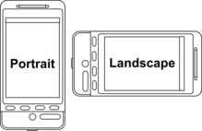

Post-impressionists continued using intense colours, thick application of paint, distinctive brushstrokes and real-life, but they wanted to show more emotion and expression in their paintings.

**Key knowledge**

* I know the primary and secondary colours.
* I know what the terms tint, tone and shade mean.
* I know which colours to mix to make a specific colour.
* I know how colour can reflect mood.
* I know what scale and proportion are.
* I know what makes a good sketch.

Year 4 – painting and drawing

