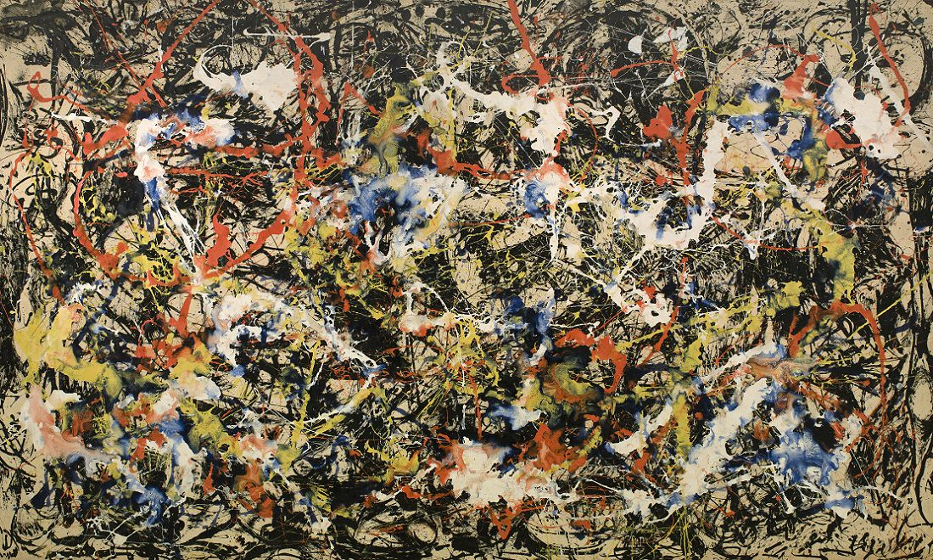

**Key vocabulary**

**Splatter**

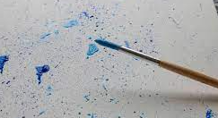

**Dripping**

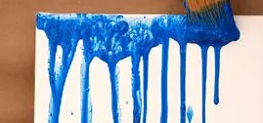

**Shade -** Adding black to a colour

**Tint -** Adding white to a colour

**Printing –** moving images onto different places using one object.

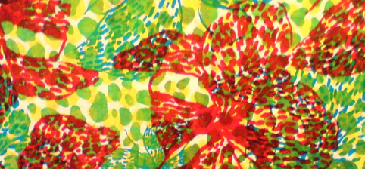

**Key skills**

1. Mix paints to create a colour wheel
2. Change the shade or tint of a colour using black, blue, white or yellow.
3. Use dripping and splattering techniques when painting
4. I can use printing techniques to mix colours
5. I can record textures and patterns

**Jackson Pollock**

Jackson Pollock was born in 1912. He got into a lot of trouble at school and was expelled twice.

Pollock didn’t paint on an easel like most painters, he put his canvases on the floor. He said it made him feel closer to the painting.

Pollock invented ‘drip painting’. He would use different tools to drip, pour and splatter paint onto the canvas from above. These paintings became very famous.

Pollock was often very unhappy and he used his art to express his feelings. Therefore, many of his paintings use dark, gloomy colours.

**Key knowledge**

1. Know how to mix colours to make a colour wheel.
2. Know that black, blue, white or yellow can change the shade of a colour.
3. Know about Jackson Pollock.
4. Know how to print and record textures and patterns.

Year 3 – printing and painting